|  |
| --- |
|  |
| Project configuration document |
|  |
|  |
| ©MetaShare Inc. |
| **11/30/2018** |

目录

1 Purpose 1

2 Integrated SanjelClientSolutionTool and eServiceMDM 1

2.1 Build CommonLibrary project 1

2.2 Build sanjelProgramManagement project 1

2.3 Build MDM project 4

2.4 Modify App.config 4

2.5 Run ProgramManagement project 5

# Purpose

Guide the developer to configure the integrated MDM and eService projects.

# Integrated SanjelClientSolutionTool and eServiceMDM

## Build CommonLibrary project

Switch to branch:

SVN address: <https://184.69.193.254:9880/SanjelCommonLibrary/branches/v20180929>

## Build sanjelProgramManagement project

Switch to branch:

SVN address: <https://184.69.193.254:9880/SanjelClientSolutionTool/branches/v20181018>

Build this project after Commonlibrary is built correctly.

Note that if there are problems with the build, please check the dll reference:

|  |  |
| --- | --- |
| DLL | Address |
| Sanjel.Common.ApiServices.dll | \SanjelCommonLibrary\Lib\netstandard2.0 |
| MasterDataManagement.Entities.dll | https://184.69.193.254:9880/SanjelCommonLibrary/branches/v20180929/Lib/netstandard2.0/ |
| Common.Core.dll | https://184.69.193.254:9880/SanjelCommonLibrary/branches/v20180929/Lib/netstandard2.0/ |

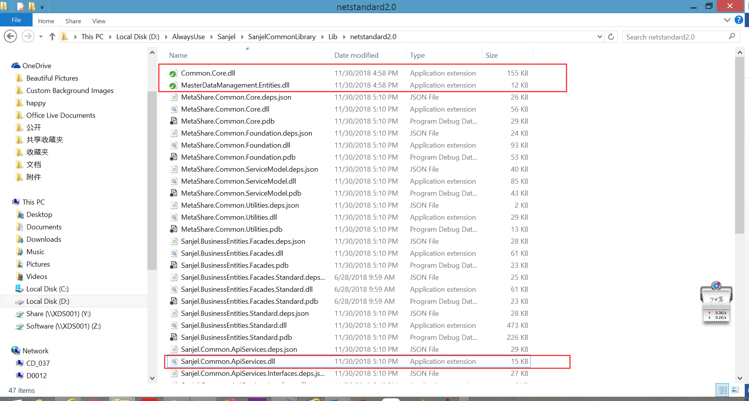

* We need to add API reference in ProgramManagements.

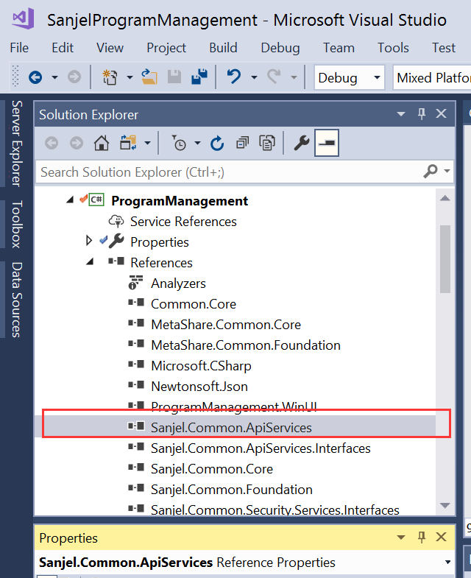

* We need to add MDM entity reference in ProgramManagements.UIProcess.

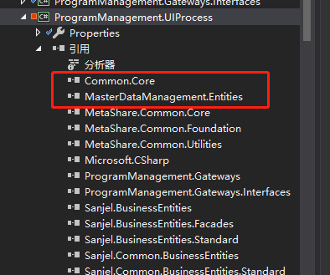

* If you need to use the API interface later, you need to add the following two DLLs in the project for development.



## Build MDM project

SVN address: <https://metashare.ca:9880/eServiceMDM/trunk>

Select the eServiceMDM project, build the API project under MasterDataManagement, as shown below:

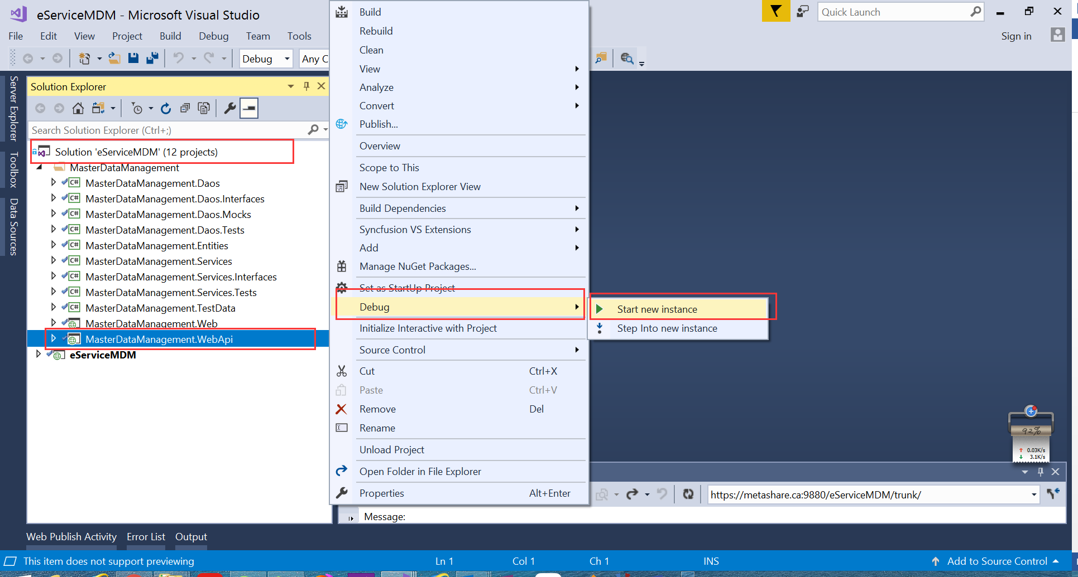

## Modify App.config

First get your api address, and copy it to App.config in ProgramManagement project.

As shown below:

<add key="EServiceApiAddress" value="http://localhost:61039/"/>

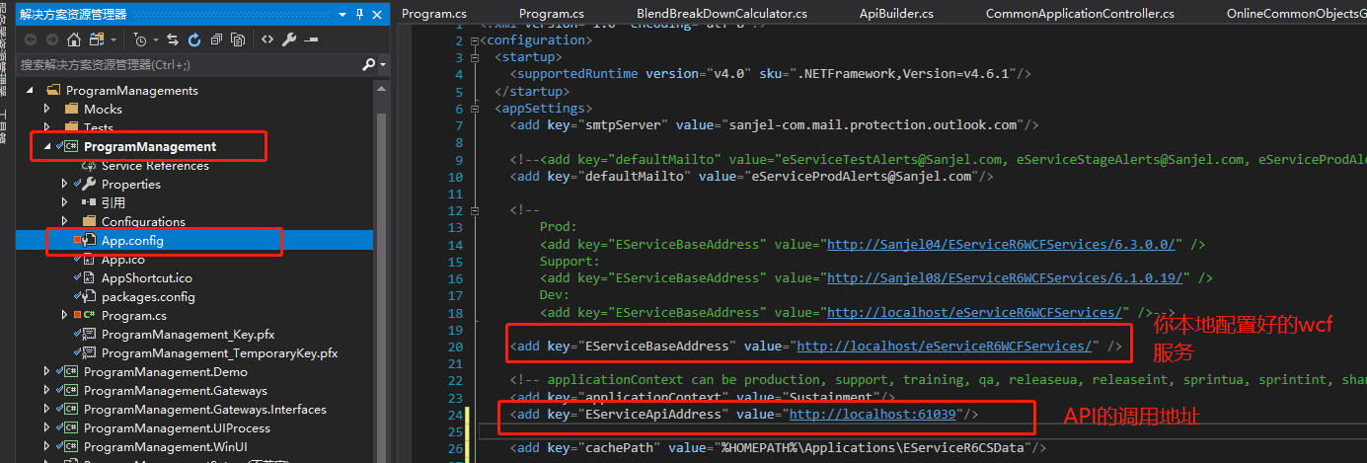

## Run ProgramManagement project

* Check your WCF service if the following exception occurs.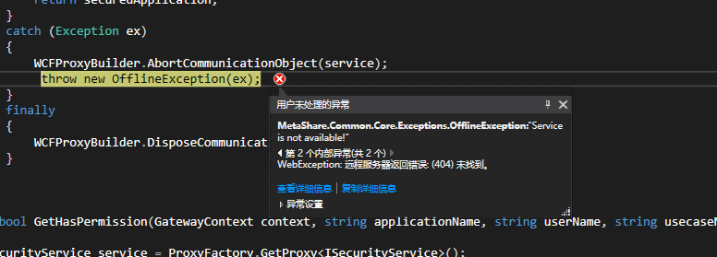
* If the integration is successful, you will see the following screen:

